Perfectly follows the input at Kp=13 Ki=0.1, Kd=0.6

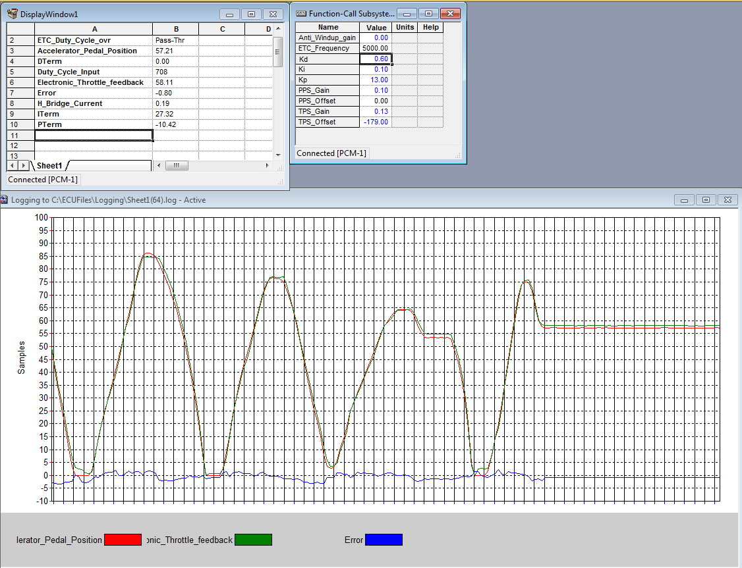

Efecct of Kd

0.6 to 0.3

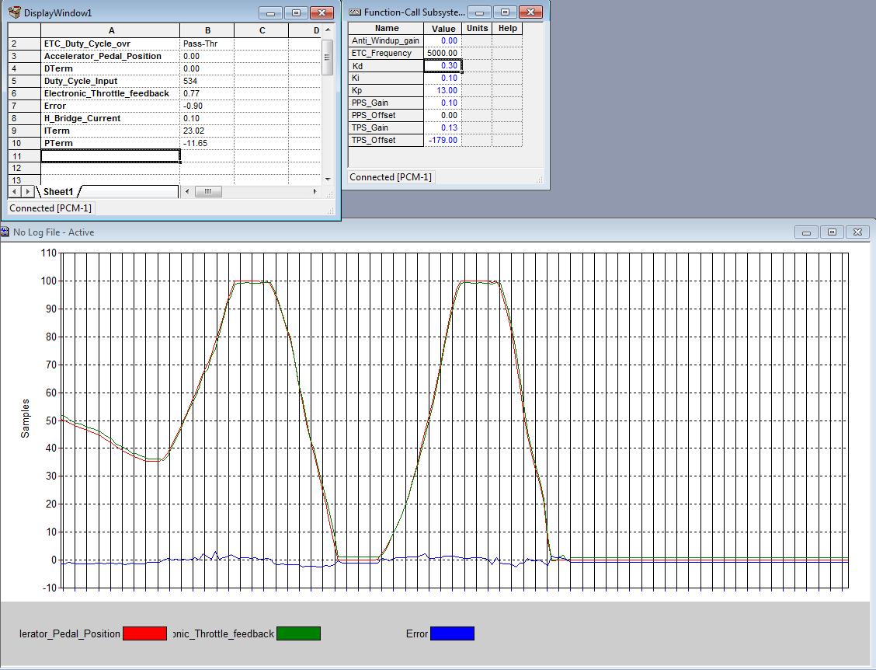

Effect of Ki 0.1 to 0.8 overshoot increases

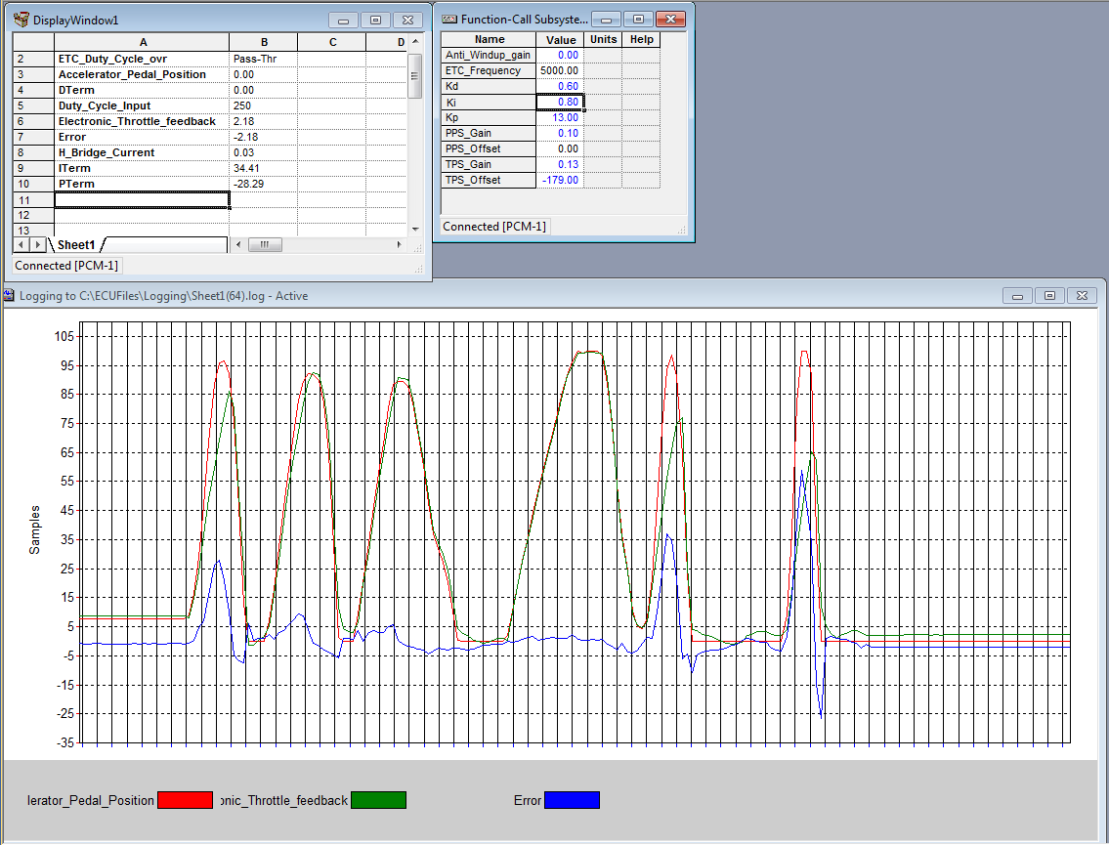

Effect of Kp

13 to 15

Oscillations occur

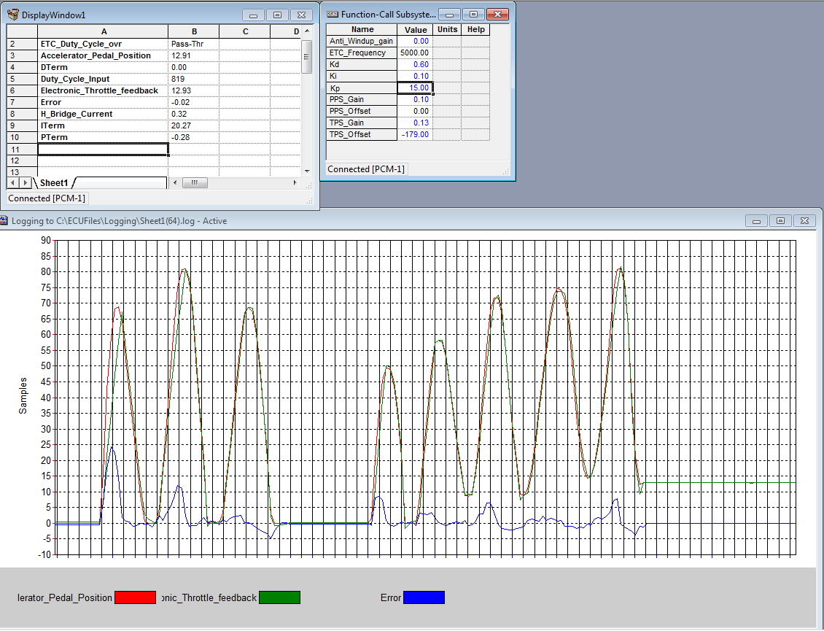

Decreasing the anti-wind up gain from 0 to -0.1

Increase in overshoot

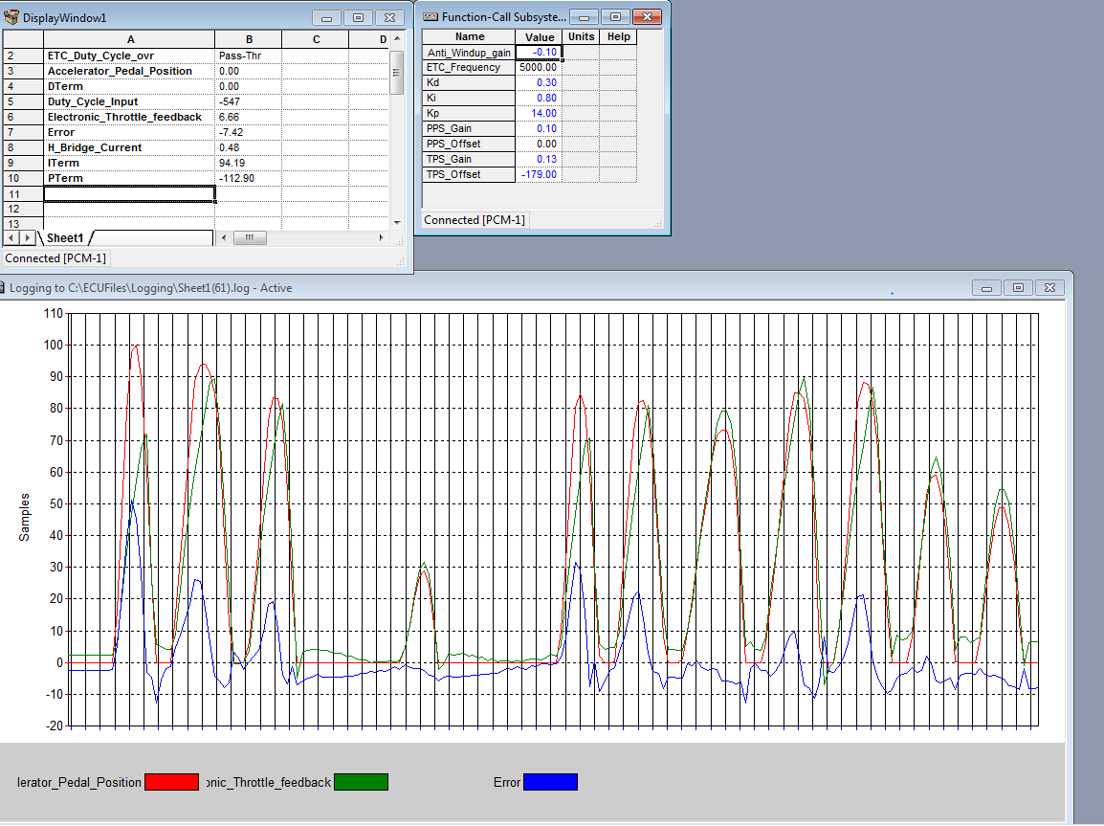

Response of Throttle FB with change in APP

